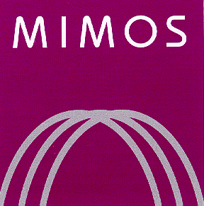

MIMOS BERHAD

(336183-H)

FREQUENTLY ASKED QUESTION (FAQ)
1 | Q: Who can apply to be a registered vendor of MIMOS Berhad?  A: Company who registered with Companies Commission of Malaysia (SSM). i.e Registrar of Company (ROC) or Registrar of Business (ROB) which owns a paid-up capital in the form of ordinary shares at RM2.00.
2 | Q: Is there any fee for the registration?  A: There is no registration fee.
3 | Q: As registered vendor, is my company guaranteed to be awarded any contracts from MIMOS?  A: No. MIMOS shall not in any way guarantee to award contracts to its registered vendor.
4 | Q: Do I need to submit any supporting documents?  A: Yes. Registrants are required to submit supporting documents accordingly. Failure to submit the documents shall render your application rejected.
5 | Q: Will MIMOS produce any certificates or letter of confirmation for the registered company?  A: No. MIMOS will only send email notification to the vendor.
6 | Q: What kind of turnaround time can I expect in regards to my registration?  A: The registration should be completed within seven (7) working days. On occasion there may be delays due to unforeseen circumstances, and in that case you will receive an email regarding the delay to reflecting this delay in processing and the date it will resume again.

Any further information, kindly contact:-
PROCUREMENT DEPARTMENT
MIMOS BERHAD
TEL:- 03-8995 5000
FAX: 03-8996 0292

Reeza Fadzlee Abdul Hamid:- ext 55610
reeza.hamid@mimos.my

Haryati Mohammed Redza:- ext 56009
haryati.redza@mimos.my

